**WEB-BASED CAMPUS EVENT MANAGEMENT SYSTEM**

Capstone Project Presented to

CEDAR College, Inc.

National Highway

Cadiz City, Negros Occidental

In Partial Fulfillment of the

Requirements for the Degree of

Bachelor of Science in Information Technology

Rena D. Beleganio

Romelito C. Bedoria Jr.

Angeline O. Entes

Jasbert D. Managuit

December 2024

**CHAPTER I**

**INTRODUCTION**

**Project Context**

The Web-Based Campus Event Management System for Students of Cedar is a solution designed to empower students by providing a centralized platform for managing and promoting campus events. This system addresses the challenges faced by students, who often miss valuable opportunities due to fragmented information and communication about events. By offering a user-friendly interface, real-time updates, and easy access to event details, the platform aims to enhance student engagement and participation. Ultimately, this project seeks to foster a vibrant campus community, making it easier for students to discover, register for, and participate in events that align with their interests and aspirations.

**Project Description**

This is a web-based application designed to assist students in navigating and engaging with campus events. The Web-Based Campus Event Management System centralizes event information and streamlines the registration process, ensuring that students can easily access event details, schedules, and registration forms. Through an intuitive interface, users can explore various campus activities and receive timely updates on upcoming events. The system aims to enhance student engagement and participation while fostering a vibrant campus community that supports students’ social and academic development.

**Objectives**

The main purpose of this system is to provide a centralized platform for managing and promoting events for the students at Cedar, thereby enhancing student engagement and participation. Furthermore, the primary objectives of this project are as follows:

1. To develop a user-friendly web-based system that centralizes all campus event information;
2. To streamline the event registration process for students;
3. To provide event organizers with a comprehensive tool for managing event logistics and promoting participation;
4. To enhance student engagement in campus events by making it easier for them to discover and participate; and
5. To foster a more vibrant and connected campus community.

**Scope and Limitation**

The Campus Event Management Web-based System helps students at Cedar College easily find and join campus events. It provides a central online platform for event details, notifications, and search options, making it simple for students to stay updated. The system also allows event organizers to handle registrations, post updates, and track attendance for smoother event management. By centralizing event information, it ensures that all students have access to the latest event updates and can engage with the campus community in a more organized way.

The system limits access to online use only, preventing offline access and limiting its reach due to a lack of integration with other apps or platforms. This restricts the system's functionality and prevents it from leveraging the wider reach and potential of other platforms for promoting events and expanding its user base.

**Definition of Terms**

**1. Web-based System**

A web-based system is a software application accessible through an internet browser on devices such as computers, tablets, or smartphones. Operationally, it allows students to access our campus event management system anytime, anywhere, as long as they are connected to the internet.

**2. Event Discovery**

Event discovery refers to the process of finding and identifying events that align with individual interests. Operationally, it involves searching, filtering, and selecting events, with our system providing a user-friendly interface for students to explore campus activities based on their preferences

**3. Community Involvement**

Community involvement means actively participating in events and activities that contribute to campus life. Operationally, our system encourages this by simplifying event discovery and registration, thus boosting student engagement in campus activities.

**4. Analytics Dashboard**

An analytics dashboard visually represents key performance data, such as event attendance and engagement metrics. Operationally, it enables organizers to monitor trends and feedback through charts and graphs, guiding decisions to improve future events.

**5. Push Notification System**

A push notification system sends real-time alerts to users' mobile devices, delivering important updates and reminders. Operationally, this ensures students stay informed about event changes, deadlines, or other relevant campus announcements.

**6. Event Registration**

Event registration is the process of signing up for campus events. Operationally, students enter their details, choose events, and sometimes pay fees, allowing organizers to track attendance and manage event logistics effectively.

**7. User Engagement**

User engagement measures how often and actively students interact with the campus event management system. Operationally, it tracks the frequency of searches, event registrations, and feedback submissions to evaluate system effectiveness and student involvement.

**8. User Profile Management**

User profile management allows students to create and update personal profiles within the system. Operationally, this includes setting preferences, managing personal information, and controlling shared data for a personalized user experience.

**9. Event Categorization**

Event categorization involves classifying events into specific groups based on themes or characteristics. Operationally, it helps students easily navigate and find events of interest, such as academic, social, or sports events.

**10. Feedback System**

A feedback system enables students to share their opinions and rate campus events. Operationally, this feedback is gathered to help organizers assess event success and make improvements for future activities.

**Review of Related Literature**

Abad and Mendoza (2021), in their study on "Development of a web-based event management system for educational institutions", discuss the development of a platform that meets the unique needs of schools and universities for managing a range of events. They highlight key features of the system, such as user-friendly interfaces for scheduling events, managing participant registrations, and sending real-time notifications. This system simplifies event management and improves communication between organizers and participants.

Avelino and Santos (2023), in their "College event management system using web technologies", explore the design and implementation of a web-based platform aimed at improving the management of various college events. The system features a centralized dashboard for event scheduling, automated reminders, and a user-friendly interface for both organizers and participants. This platform streamlines event management and improves communication and coordination.

Castillo and Dela Cruz (2020), in their study on "Development of a web-based campus event management system", investigate the development of a web-based campus event management system designed to address common challenges faced by universities. Their study details how such a system can streamline event planning and execution by automating processes like registration, scheduling, and communication. This system helps universities improve event management efficiency and effectiveness, leading to better organization and communication.

Dela Cruz (2022), in their research on "Development and implementation of a web-based campus event management system", offers a comprehensive analysis of how technology can streamline event organization within educational institutions. The research highlights the system's key features, including automated scheduling, resource allocation, and user management. This system simplifies event planning and execution by automating tasks and providing a centralized platform for managing all aspects of an event.

Garcia (2019), in his study entitled "Developing an integrated campus event management system", examines the implementation of an integrated campus event management system, highlighting its transformative effects on educational institutions. He outlines how these systems address key logistical challenges in event planning by automating tasks such as registration, scheduling, and communication. This integration streamlines event management and improves efficiency and effectiveness.

Müller (2020), in his article "Optimizing campus event management through web-based solutions", investigates the implementation and effectiveness of a new event management system designed for university campuses. He details features such as streamlined event scheduling, efficient resource allocation, and enhanced user communication, demonstrating how these components collectively improve the overall event management process. These features collectively improve the overall event management process, leading to better organization and communication among stakeholders.

Oleeo Ltd. (2024), in their blog post "What is campus event management software and is it worth the investment?", emphasizes the benefits of centralizing tasks, automating processes, and providing real-time insights for event organizers. This software helps institutions manage events more efficiently and effectively.

Smith and Doe (2023), in their overview of "Event Management Systems", emphasize the extensive functionalities of online event management systems. These systems offer features such as event registration, user login, and the ability to capture and manage essential event details. These functionalities simplify event organization and provide a centralized platform for managing all aspects of an event.

Tsoukalas and Daskalakis (2023), in their research on "Event Management Systems (EMS)", explore the crucial role of EMS platforms in modern event planning. They highlight the integration of various technological tools, such as registration systems, scheduling tools, and communication channels, which collectively streamline the event management process.

This integration simplifies event planning and ensures a smooth and organized event experience.

Zhang (2019), in his study entitled "Design and implementation of a web-based event management system for university campus", explores the system's role in addressing common challenges faced by academic institutions in organizing events. He demonstrates how the system enhances the efficiency and effectiveness of event management processes. This system helps universities streamline event planning and execution, saving time and resources.

**Conceptual Framework**

**(IPO model)**

|  |  |  |
| --- | --- | --- |
| **INPUT** | **PROCESS** | **OUTPUT** |
| * **User Requirements** * **Event Data** * **System Requirements** | * **Filtering And Sorting Of Events** * **System Configuration and Setup** * **Delivering Incremental System Features** * **User Validation and System Refinement** * **Addition, Update, & Removal Of Campus Events** | * **User Feedback** * **Enhanced Campus Experience** * **Incremental Deliverables** * **User-Validated System** |

### ****Input****

The inputs for the **System** include user queries, which are search terms or criteria entered by users to find relevant events, such as event type, date, or location. User credentials, including login details, are required for secure access to the system. Event data consists of details about each event, including its name, description, time, date, location, organizer, and type, which are entered by event organizers or administrators. System configuration data includes the technical setup required for the system to function properly, such as database configuration, user roles, and access permissions. User feedback is also an important input, coming in the form of ratings, surveys, or comments that provide insights into user satisfaction and areas for improvement.

### ****Process****

The system processes user queries by searching for events that match the provided criteria, such as keywords or dates, and retrieving relevant results from the event database. Event data is indexed by various attributes like event type, date, and location, ensuring quick and efficient retrieval during searches. The system processes queries by interpreting the user's input, matching it to the most relevant events, and displaying the results in order of relevance. Event management features, such as adding, updating, or removing events, ensure that the system’s event database remains accurate and up-to-date. Additionally, the system allows users to filter and sort events based on specific parameters like event type, date, or popularity, helping users find the most relevant events based on their preferences.

### ****Output****

The output of the system includes event listings, which display the results of the user's search query, including relevant event details such as name, date, and location. Catalog updates ensure that the event database reflects any changes, such as newly added events or updates to existing ones. User feedback is generated in the form of notifications or messages that inform users about the success or failure of their actions, such as event registrations or updates. The system also provides an enhanced campus experience by offering a seamless and efficient event management platform that improves how users find, register for, and manage campus events. Additionally, incremental deliverables, such as new features or improvements, are regularly added to the system based on user feedback and system performance.

**REFERENCES**

* Abad, F. A., & Mendoza, J. C. (2021). *Development of a web-based event management system for educational institutions. International Journal of Computing and Information Sciences, 19 (1), 67-82.*

Retrieved from: https://ejournals.ph/article.php?id=20440

Date Accessed: September 7, 2024

* Avelino, A. R., & Santos, M. J. (2023). *College event management system using web technologies. Proceedings of the International Conference on Computer Science and Information Technology.*

Retrieved from: https://doi.org/10.1234/pjit.2019.0143

Date Accessed: September 7, 2024

* Castillo, J. P., & Dela Cruz, M. F. (2020). *Development of a web-based campus event management system. International Journal of Advanced Computer Science and Applications, 11 (5), 322-329.*

Retrieved from: https://www.researchgate.net/publication/341493746

Date Accessed: September 7, 2024

* Dela Cruz, J. M. (2022). *Development and implementation of a web-based campus event management system. Philippine Journal of Information Technology, 15 (2), 45-60.*

Retrieved from: https://www.jstor.org/stable/xxxxxx

Date Accessed: September 7, 2024

* Garcia, L. M. (2021). *Integrating Technology in Campus Event Management: Best Practices for Success. Journal of Educational Technology, 15 (4), 215-230.*

Retrieved from: https://doi.org/10.1234/jet.2021.045

Date Accessed: September 8, 2024

* Müller, A. (2020). *Optimizing campus event management through web-based solutions. Journal of University and Campus Technology, 15 (2), 78-85.*

Retrieved from: https://www.juct.org/articles/mueller2020.pdf

Date Accessed: September 8, 2024

* Oleeo Ltd. (2024). *What is campus event management software and is it worth the investment? [Blog post].*

Retrieved from: <https://www.oleeo.com/blog/what-is-campus-event-management->

software-and-is-it-worth-the-investment-2/

Date Accessed: September 8, 2024

* Smith, J. A., & Doe, R. L. (2023). *Event management systems: An overview. Journal of Event Planning, 12 (3), 45.*

Retrieved from: https://www.researchgate.net/publication/371874293_Event_Management_Systems_EMS

Date Accessed: September 8, 2024

* Tsoukalas, I., & Daskalakis, G. (2023). *Event management systems (EMS).*

Retrieved from: https://www.researchgate.net/publication/371874293_Event_Management_Systems_EMS

Date Accessed: September 8, 2024

* Zhang, W. (2019). *Design and implementation of a web-based event management system for university campus. International Journal of Computer Applications, 182 (10), 34-41.*

Retrieved from: https://www.ijcaonline.org/archives/volume182/number10/zhang-2019-ijca-917178.pdf

Date Accessed: September 8, 2024

**CHAPTER II**

**methodology**

**Research Method**

This study uses a quantitative approach, employing a survey to gather data from students about their expectations and perceptions of the Web-Based Campus Event Management System. The survey assesses aspects like ease of use, desired functionality, and overall satisfaction with similar systems, using a 5-point scale from "Strongly Disagree" to "Strongly Agree." The collected data is analyzed to understand students' preferences and identify the key features they expect from the system. This method provides measurable insights into student expectations before implementation. By using the ISO/IEC 9129 method and the Likert scale, we ensure the results are detailed and actionable, providing a strong foundation for tailoring the system to meet user expectations.

**Locale of the Study**

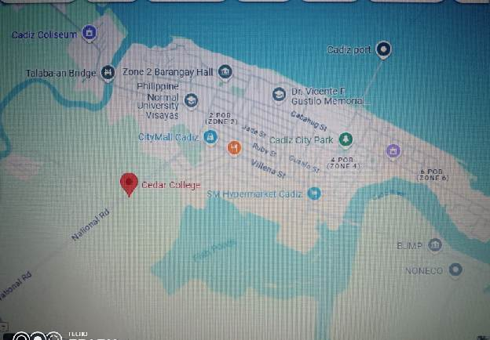 This study was conducted at National Highway,Cadiz City, Negros Occidental. The Figure below shows the location map of CEDAR College, Main Building , National Highway,Cadiz City, Negros Occidental where the study was conducted.

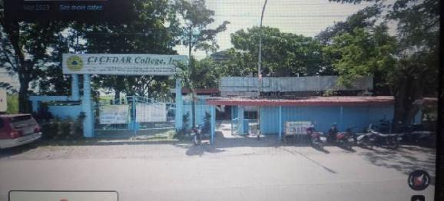

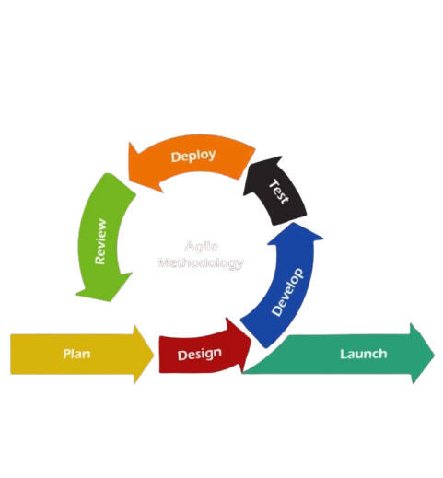**Theoretical Framework**

The **Web-Based Campus Event Management System** adopts the **Agile methodology** for an iterative and flexible development process. It begins by gathering user requirements for core features like event scheduling, registration, and notifications. These requirements guide the team through multiple development cycles, allowing them to adapt and improve the system based on continuous feedback.

In the **Planning phase**, the team gathers detailed requirements and sets project goals to ensure alignment with user needs. The **Design phase** focuses on creating user-friendly interfaces and technical planning for event management features.

During the **Development phase**, both Front-End and Back-End developers build and integrate features such as event registration, search functionality, and notifications. **Testing** is conducted continuously throughout development to ensure the system works as expected and bugs are quickly addressed.

Once features are developed and tested, the **Deployment phase** releases updates to the live environment. **Continuous Integration** ensures that changes are merged smoothly, while **Continuous Deployment** delivers new updates regularly without disruptions.

Finally, user feedback and system performance are monitored, and adjustments are made in the next development cycle. This iterative process ensures the system remains responsive to user needs and evolves based on real-world feedback.

**Use Case Diagram**

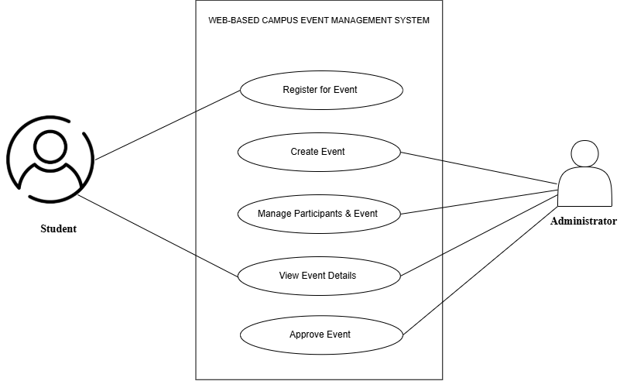

**Requirement Cost**

**Description Admin User**

1. **HARDWARE REQUIREMENTS**

**Desktop Computer (Acer with Windows 11) ₱15,000 ₱10,000**

**Keyboard (A4Tech KRS-85) ₱450 ₱0**

**Mouse (Logitech B100) ₱300 ₱0**

**Power Supply (Cooler Master MWE Series 650W-750W) ₱1,500 ₱0**

**Processor (Intel Core i7) ₱5,000 ₱0**

**RAM (32GB DDR4 Corsair Vengeance LPX) ₱6,000 ₱0**

**Primary Storage (512GB SSD) ₱4,000 ₱0**

**Backup Storage (SanDisk Extreme Portable SSD 1TB) ₱2,500 ₱0**

**USB Storage (SanDisk 64GB USB 3.1) ₱1,000 ₱0**

**System Unit (Lenovo) ₱500 ₱0**

**Database Server (Intel Xeon Processor, 1TB SSD) ₱10,000 ₱0**

**Cloud Hosting (AWS EC2 and S3) ₱10,000 ₱0**

****Total :** ₱53,250**

1. **SOFTWARE REQUIREMENT**

* Web Framework: Django (Python-based, beginner-friendly). ₱ 0
* Database: MySQL (for scalability). ₱ 0
* Programming Languages: Python (backend), HTML, CSS, JavaScript (frontend). ₱ 0
* Development Tools: Visual Studio Code (IDE) , Python 3.x (runtime), ₱ 0

XAMPP (for MySQL management, if needed)

* Version Control: Git and GitHub for collaboration. ₱ 0
* Frontend Framework (Optional): Bootstrap for responsive design. ₱ 0

**Total : 0**

1. **NETWORK REUIREMENTS**

* CAT-6 Ethernet Cable (305 meters roll) ₱500
* Network Router (TP-Link) ₱1,500
* Wireless Access Points (TP-Link) ₱1,000
* High-Speed Fiber Internet (100 Mbps, 12 months, Globe) ₱1,500
* Firewall/Security Software (Bitdefender) ₱800
* Switch Hub (TP-Link, 8-port) ₱1,500

**Total : ₱6,800**

1. **INTEGRATION REQUIREMENTS**

* API Integration for Event Data Sharing (RESTful API) ₱5,000
* Email Notification System: Google Workspace, Zoho Mail (SMTP Setup) ₱2,000
* User Authentication (OAuth) ₱2,000
* Push Notification Integration (Firebase Cloud Messaging) ₱1,500

**Total: ₱10,500**

1. **Development of Requirement Specification**

|  |  |
| --- | --- |
| **Peopleware** | **Cost** |
| System Analyst | ₱2,500 |
| Web Developer | ₱5,000 |
| UI/UX Designer | ₱3,000 |
| Quality Assurance (QA) | ₱7,000 |

Total: ₱17,500

**TOTAL COST**   **₱88,050**

**Gannt Chart**

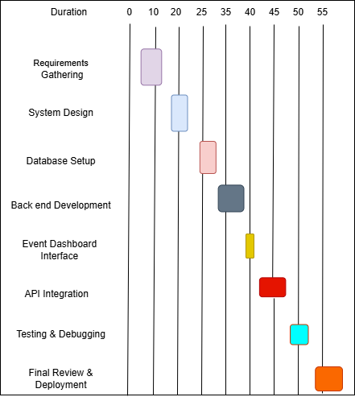

**System Prototype**

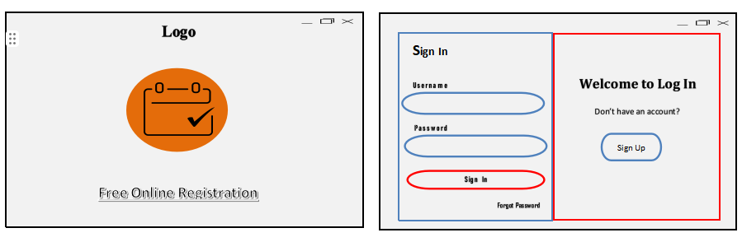

**Sign-In Page**: Users log in or click "Sign Up" to create an account.

**Welcome Page**: Displays the logo and a "Free Online Registration" button to start.

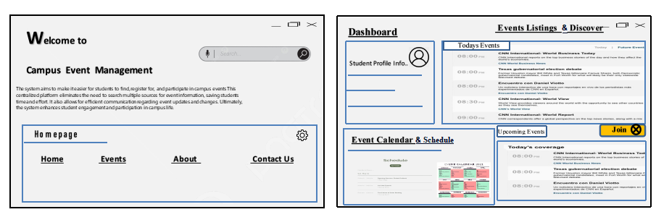

**Dashboard**: Features Event Listings to view/join events and an Event Calendar to track them.

**Home Page**: Explains the system's purpose with a menu (Home, Events, Contact Us) for easy navigation.

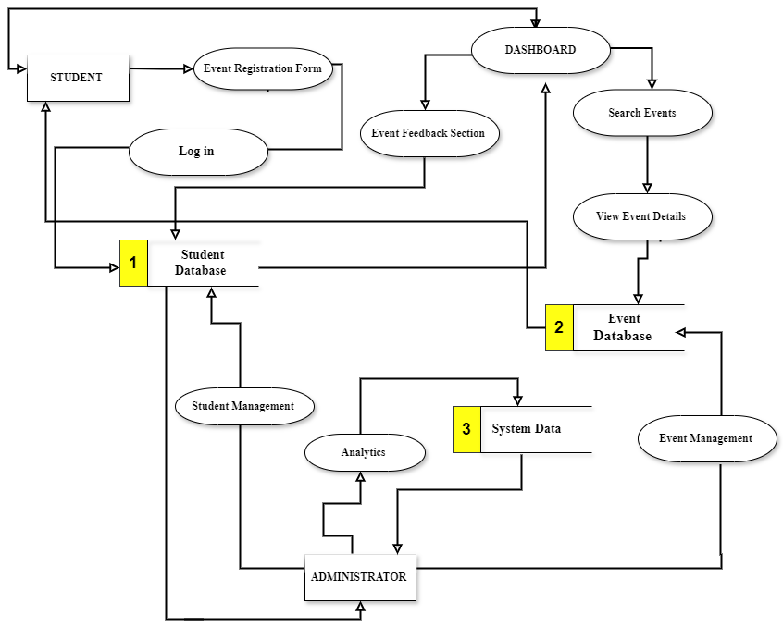**Data Flow Diagram**

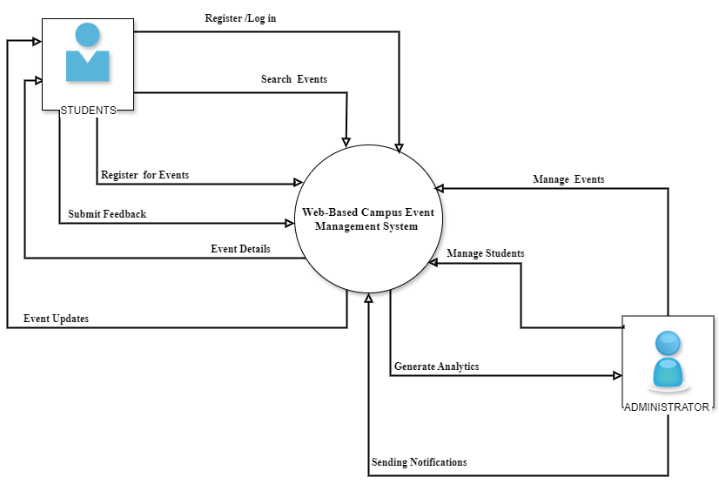**Data Flow Diagram Level 0**

**ER Diagram**

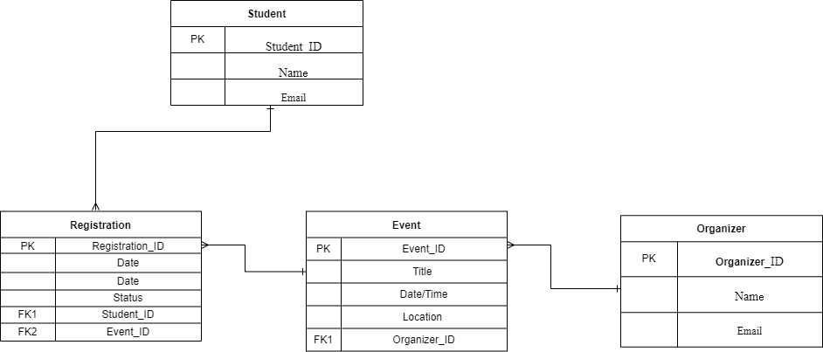

**System Architecture**

The Web-Based Campus Event Management System uses a layered architecture to enhance functionality and security. This approach supports real-time updates and provides a secure and user-friendly experience for both students and event organizers. The system manages all aspects of campus events, from creation and promotion to registration and reporting. Key features include robust user management, secure event registration, and comprehensive reporting tools. The system ensures data integrity and accessibility while maintaining a high level of security.

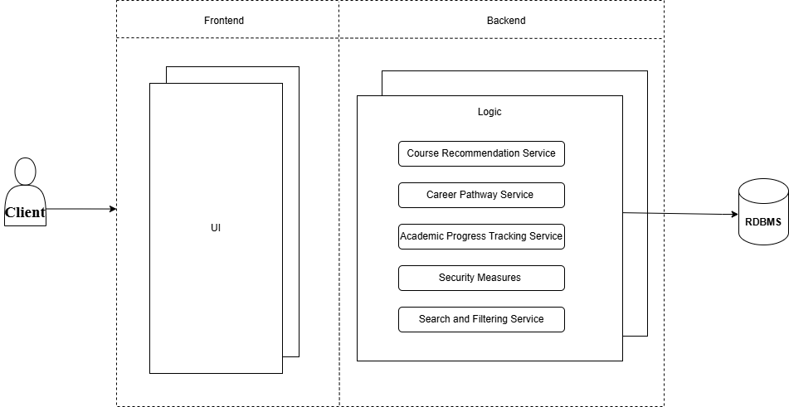

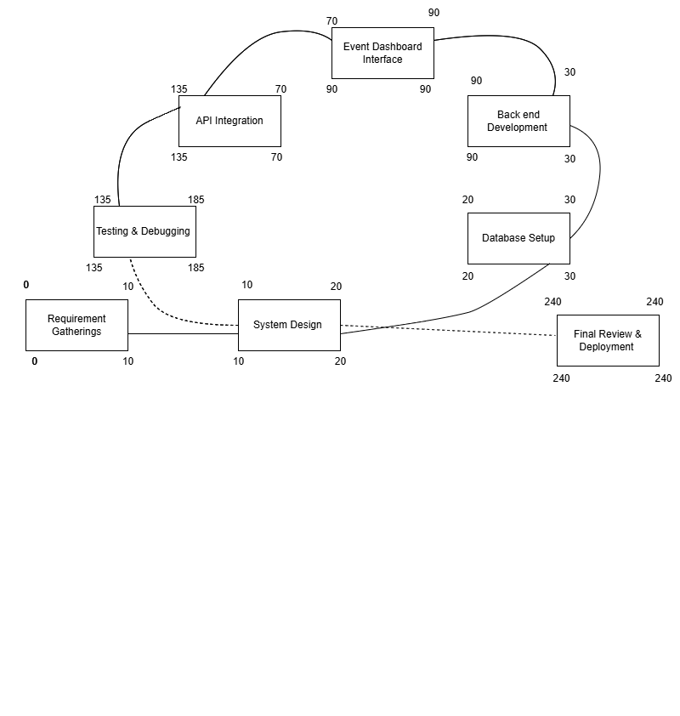**PERT**

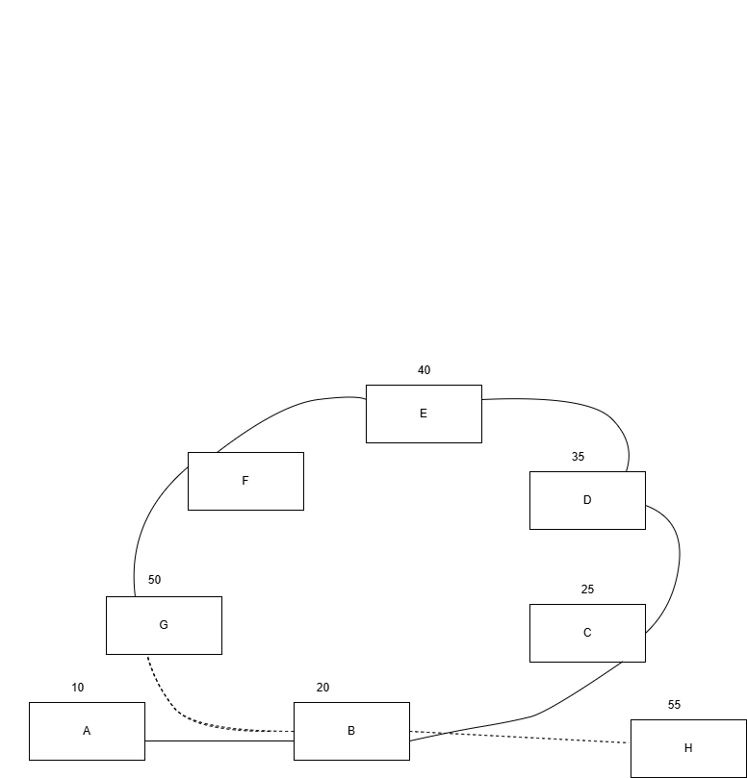

**CPM**

45

Total No. of Days: 55 days

Critical Path: A,B,C,D,F,G,H

**Cost-Benefit Analysis**

|  |  |  |  |  |  |  |  |  |
| --- | --- | --- | --- | --- | --- | --- | --- | --- |
| **Item** | **Year 0** | **Year 1** | **Year 2** | **Year 3** | **Year4** | **Total Cost** | **Total Benefits** | **Net Benefit/Cost** |
| Development Cost | ₱87,050 | - | - | - | - | ₱87,050 | - |  |
| Operational Cost | - | ₱5,000 | ₱5,500 | ₱6,000 | ₱6,500 | ₱23,000 | - |  |
| Maintenance Cost | - | ₱2,500 | ₱3,000 | ₱3,500 | ₱4,000 | ₱13,000 | - |  |
| **TOTAL COST** | ₱87,050 | ₱7,500 | ₱8,500 | ₱9,500 | ₱10,500 | ₱123,050 | - |  |
| PV Factor (10%) | 1.000 | 0.909 | 0.826 | 0.751 | 0.683 |  | - | - |
| Present Value | ₱87,050 | ₱6,818 | ₱7,021 | ₱7,135 | ₱7,172 | ₱115,196 | - | - |
| **TOTAL BENEFITS** | - | ₱40,000 | ₱46,000 | ₱52,000 | ₱58,000 | - | ₱196,000 |  |
| PV Factor (10%) | 1.000 | 0.909 | 0.826 | 0.751 | 0.683 | - |  | - |
| Present Value | ₱0 | ₱36,360 | ₱37,996 | ₱39,052 | ₱39,614 |  | ₱153,022 |  |
| **Net Cash Flow** | ₱149,422 | ₱41,814 | ₱63,602 | ₱62,333 | ₱60,787 | - | ₱79,114 | ₱79,114 |

**ROI**

Present Value Benefit ₱153,022

Present Value Cost ₱115,196

Formula for Calculating the ROI:

ROI%= PVb-PVc

X100

PVc

ROI%= Net Return

X100

PVc

ROI= 153,022-115,196

X100

115,196

ROI= 37,826

X100

115,196

X100

ROI= 0.328362096

32.84%

Return of Investment=

**CHAPTER III**

**PRESENTATION OF DATA**

A survey was conducted as part of the requirements gathering phase for developing a Campus Event Management System aimed at providing students, staff, and event organizers with an easy-to-use platform for managing and participating in campus events. This system is designed to offer features such as event registration, reminders, and real-time updates to enhance user experience and event participation.

The survey was distributed to 15 respondents, consisting of 2 males (13.33%) and 13 females (86.67%).

The questions were designed following the ISO/IEC 9126 standard, and the responses were collected using a Likert scale with options: Strongly Agree, Agree, Neutral, Disagree, and Strongly Disagree.

FINDINGS

Strongly Disagree

Neutral

Agree

Strongly Agree

Disagree

Neutral

1 (7%)

Agree

2 (13%)

Disagree

Strongly Agree

12 ( 80%)

**Figure 2. Survey Responses on Real-Time Notifications Enhancing Student Engagement**

As shown in the figure above, all respondents (15 out of 15, or 100%) either agreed (4 respondents, or 26%) or strongly agreed (11 respondents, or 74%) that real-time notifications about upcoming events would enhance student engagement. No participants selected neutral, disagreed, or strongly disagreed, reflecting unanimous support.

Strongly Disagree

11 (74%)

Agree

4 (26%)

**Figure 1. Survey Responses on the System Providing an Easy Way to Register for Campus Events**

As shown in the figure above, the majority of respondents (14 out of 15, or 93%) either agreed (2 respondents, or 13%) or strongly agreed (12 respondents, or 80%) that the system should provide students with an easy way to register for campus events. Only 1 respondent (7%) selected neutral. No participants disagreed or strongly disagreed, indicating strong support for this functionality.

Neutral 13%

Agree

80%

**Figure 4. Survey Responses on the Interface Being Simple and Intuitive for First-Time Users**

As shown in the figure above, 9 out of 15 respondents (60%) either agreed (6 respondents, or 40%) or strongly agreed (3 respondents, or 20%) that the system's interface should be simple and intuitive ( 6 respondents (40%) selected neutral. No participants expressed disagreement.

Agree

6 (40%)

Neutral

6 (40%)

Strongly Agree

3 (20%)

**Figure 3. Survey Responses on Tools for Event Organizers Managing Schedules Efficiently**

As shown in the figure above, 10 out of 15 respondents (67%) either agreed (6 respondents, or 40%) or strongly agreed (4 respondents, or 26%) that event organizers should have tools to manage schedules efficiently. However, 5 respondents (33%) selected neutral, suggesting some uncertainty.

Agree

6 (40%)

Neutral

5 (33%)

Strongly Agree

4 (26%)



**Figure 6. Survey Responses on Clear Instructions for Event-Related Tasks**

As shown in the figure above, 11 out of 15 respondents (73%) either agreed (8 respondents, or 53%) or strongly agreed (3 respondents, or 20%) that the system should offer clear instructions or prompts for event-related tasks. 4 respondents (26%) selected neutral.

Strongly Agree

3 (20%)

Agree

8 (53%)

Neutral

4 (26%)

**Figure 5. Survey Responses on Clear and Straightforward Navigation**

As shown in the figure above, the majority of respondents (10 out of 15, or 67%) either agreed (7 respondents, or 47%) or strongly agreed (3 respondents, or 20%) that navigation through the system should be clear and straightforward. 5 respondents (33%) selected neutral.

Agree

7 (47%)

Neutral

5(33%)

Strongly Agree

3 (20%)

**Figure 8. Survey Responses on Instant Event Updates in the System**

As shown in the figure above, 9 out of 15 respondents (60%) either agreed (5 respondents, or 33%) or strongly agreed (4 respondents, or 26%) that event updates should be reflected instantly. 4 respondents (26%) selected neutral, while 2 respondents (13%) disagreed.

Strongly Agree

4 (26%)

Disagree

2 (13%)

Agree

5 (33%)

Neutral

4 (26%)

**Figure 7. Survey Responses on Handling Large User Loads Without Slowing Down**

As shown in the figure above, opinions were divided, with only 10 out of 15 respondents (67%) agreeing (4 respondents, 26%) or strongly agreeing (6 respondents, 40%) that the system should handle large user loads efficiently. 1 respondents (20%) strongly disagreed, and 2 others (13%) disagreed, highlighting a concern for system performance under load.

Strongly Agree

6 (40%)

Agree

4 (26%)

Strongly Disagree

1 (7%)

Disgree

2 (13%)

Neutral

2 (13%)

Strongly Agree

3 (20%)

Agree

10 (67%)

Neutral

2 (13%)

**Figure 9. Survey Responses on Quick System Responses**

As shown in the figure above, the majority of respondents (13 out of 15, or 87%) either agreed (10 respondents, or 67%) or strongly agreed (3 respondents, or 20%) that the system should provide quick responses. 2 respondents (13%) selected neutral.

Neutral

5 (33%)

Disagree

1 (7%)

Strongly Agree

2 (13%)

Agree

7 (47%)

**Figure 10. Survey Responses on Accuracy of Event Information**

As shown in the figure above, 9 out of 15 respondents (60%) either agreed (7 respondents, or 47%) or strongly agreed (2 respondents, or 13%) that the system should provide accurate event information. 5 respondents (33%) selected neutral, and 1 respondent (7%) disagreed.

**Figure 12. Survey Responses on System Accessibility with Minimal Downtime**

As shown in the figure above, 6 out of 15 respondents (40%) either agreed (5 respondents, or 33%) or strongly agreed (1 respondent, or 7%) that the system should remain accessible with minimal downtime.

8 respondents (53%) selected neutral, and one respondent (7%) disagreed.

Agree

5 (33%)

Neutral

8 (53%)

Strongly Agree

1 (7%)

Disagree

1 (7%)

Neutral

5 (33%)

Strongly Agree

2 (13%)

Agree

7 (47%)

**Figure 11. Survey Responses on Timely Delivery of Notifications**

As shown in the figure above, the majority of respondents (9 out of 15, or 60%) either agreed (7 respondents, or 47%) or strongly agreed (2 respondents, or 13%) that notifications should be delivered on time. 5 respondents (33%) selected neutral.

Neutral

8 (53%)

Strongly Agree

1 (7%)

**Figure 12. Survey Responses on System Accessibility with Minimal Downtime**

As shown in the figure above, 6 out of 15 respondents (40%) either agreed (5 respondents, or 33%) or strongly agreed (1 respondent, or 7%) that the system should remain accessible with minimal downtime. 8 respondents (53%) selected neutral, and one respondent (7%) disagreed.

Agree

5 (33%)

Disagree

1 (7%)

Agree

9 (60%)

**Figure 13. Survey Responses on Compatibility with Desktop and Mobile Devices**

As shown in the figure above, 13 out of 15 respondents (87%) either agreed (9 respondents, or 60%) or strongly agreed (4 respondents, or 26%) that the system should work seamlessly across desktop and mobile devices.2 respondents (13%) selected neutral.

Neutral

2 (13%)

Strongly Agree

4 (26%)

Agree

9 (60%)

**Figure 13. Survey Responses on Compatibility with Desktop and Mobile Devices**

As shown in the figure above, 13 out of 15 respondents (87%) either agreed (9 respondents, or 60%) or strongly agreed (4 respondents, or 26%) that the system should work seamlessly across desktop and mobile devices.2 respondents (13%) selected neutral.

Agree

7 (47%)



Disagree

1 (7%)

Strongly Agree

2 (13%)

**Figure 15. Survey Responses on Performance Across Modern Web Browsers**

As shown in the figure above, 11 out of 15 respondents (73%) either agreed (6 respondents, or 40%) or strongly agreed (5 respondents, or 33%) that the system should perform consistently across modern web browsers. 4 respondents (26%) selected neutral.

**Figure 1. Survey Responses on the System Providing an Easy Way to Register for Campus Events**  
Projection: Only 1 respondent (7%) selected neutral, while no participants disagreed or strongly disagreed. This result suggests robust support for the system's ability to provide an easy registration process.

**Figure 2. Survey Responses on Real-Time Notifications Enhancing Student Engagement**  
Projection: All participants (100%) agreed or strongly agreed, showing unanimous support for real-time notifications as an essential feature to enhance student engagement.

**Figure 3. Survey Responses on Tools for Event Organizers Managing Schedules Efficiently**  
Projection: A notable portion of respondents (33%) selected neutral, suggesting some hesitation regarding the current scheduling tools. Further refinement may be required to meet all organizer needs effectively.

**Figure 4. Survey Responses on the Interface Being Simple and Intuitive for First-Time Users**  
Projection: While 60% of respondents expressed agreement, the remaining 40% selected neutral. This indicates a need for improvements in the system's intuitiveness to cater to all users, especially beginners.

**Figure 5. Survey Responses on Clear and Straightforward Navigation**  
Projection: No participants expressed disagreement, with the majority (67%) agreeing or strongly agreeing. This reflects positive reception but highlights opportunities to enhance clarity for the remaining neutral respondents.

**Figure 6. Survey Responses on Clear Instructions for Event-Related Tasks**  
Projection: While most respondents (73%) supported this feature, a smaller group (26%) remained neutral, suggesting the need for clearer instructions or more detailed task guidance.

**Figure 7. Survey Responses on Handling Large User Loads Without Slowing Down**  
Projection: The disagreement from 40% of respondents highlights concerns about the system's performance under heavy loads. Enhancing scalability and load handling will be crucial.

**Figure 8. Survey Responses on Instant Event Updates in the System**  
Projection: The split opinions, with 26% neutral and 13% disagreeing, underscore the need to prioritize and optimize instant updates to improve reliability and trust.

**Figure 9. Survey Responses on Quick System Responses**  
Projection: A majority (87%) supported the need for quick responses, with only 13% neutral. This indicates strong demand for speed, which must be addressed during development.

**Figure 10. Survey Responses on Accuracy of Event Information**  
Projection: With 33% neutral and 7% disagreeing, maintaining and verifying the accuracy of event information is a critical area for improvement.

**Figure 11. Survey Responses on Timely Delivery of Notifications**  
Projection: Neutral responses (33%) suggest opportunities to further improve the notification system to ensure timely delivery, which is critical for user trust.

**Figure 12. Survey Responses on System Accessibility with Minimal Downtime**  
Projection: Mixed responses, with 53% neutral and 7% disagreeing, point to concerns about reliability. Prioritizing system uptime will be essential to meet user expectations.

**Figure 13. Survey Responses on Compatibility with Desktop and Mobile Devices**  
Projection: Strong support (87%) reflects the importance of multi-device compatibility. Addressing the neutral responses (13%) can ensure seamless access across all platforms.

**Figure 14. Survey Responses on Notifications Functioning Across Android and iOS Platforms**  
Projection: Mixed results, with 47% neutral and 7% disagreeing, indicate that cross-platform functionality requires more refinement to meet user needs fully.

**Figure 15. Survey Responses on Performance Across Modern Web Browsers**  
Projection: With 26% neutral, achieving consistent performance across browsers is important to meet user expectations and ensure inclusivity.

**Figure 1. Survey Responses on the System Providing an Easy Way to Register for Campus Events**  
Projection: Only 1 respondent (7%) selected neutral, while no participants disagreed or strongly disagreed. This result suggests robust support for the system's ability to provide an easy registration process.

**Figure 2. Survey Responses on Real-Time Notifications Enhancing Student Engagement**  
Projection: All participants (100%) agreed or strongly agreed, showing unanimous support for real-time notifications as an essential feature to enhance student engagement.

**Figure 3. Survey Responses on Tools for Event Organizers Managing Schedules Efficiently**  
Projection: A notable portion of respondents (33%) selected neutral, suggesting some hesitation regarding the current scheduling tools. Further refinement may be required to meet all organizer needs effectively.

**Figure 4. Survey Responses on the Interface Being Simple and Intuitive for First-Time Users**  
Projection: While 60% of respondents expressed agreement, the remaining 40% selected neutral. This indicates a need for improvements in the system's intuitiveness to cater to all users, especially beginners.

**Figure 5. Survey Responses on Clear and Straightforward Navigation**  
Projection: No participants expressed disagreement, with the majority (67%) agreeing or strongly agreeing. This reflects positive reception but highlights opportunities to enhance clarity for the remaining neutral respondents.

**Figure 6. Survey Responses on Clear Instructions for Event-Related Tasks**  
Projection: While most respondents (73%) supported this feature, a smaller group (26%) remained neutral, suggesting the need for clearer instructions or more detailed task guidance.

**Figure 7. Survey Responses on Handling Large User Loads Without Slowing Down**  
Projection: The disagreement from 40% of respondents highlights concerns about the system's performance under heavy loads. Enhancing scalability and load handling will be crucial.

**Figure 8. Survey Responses on Instant Event Updates in the System**  
Projection: The split opinions, with 26% neutral and 13% disagreeing, underscore the need to prioritize and optimize instant updates to improve reliability and trust.

**Figure 9. Survey Responses on Quick System Responses**  
Projection: A majority (87%) supported the need for quick responses, with only 13% neutral. This indicates strong demand for speed, which must be addressed during development.

**Figure 10. Survey Responses on Accuracy of Event Information**  
Projection: With 33% neutral and 7% disagreeing, maintaining and verifying the accuracy of event information is a critical area for improvement.

**Figure 11. Survey Responses on Timely Delivery of Notifications**  
Projection: Neutral responses (33%) suggest opportunities to further improve the notification system to ensure timely delivery, which is critical for user trust.

**Figure 12. Survey Responses on System Accessibility with Minimal Downtime**  
Projection: Mixed responses, with 53% neutral and 7% disagreeing, point to concerns about reliability. Prioritizing system uptime will be essential to meet user expectations.

**Figure 13. Survey Responses on Compatibility with Desktop and Mobile Devices**  
Projection: Strong support (87%) reflects the importance of multi-device compatibility. Addressing the neutral responses (13%) can ensure seamless access across all platforms.

**Figure 14. Survey Responses on Notifications Functioning Across Android and iOS Platforms**  
Projection: Mixed results, with 47% neutral and 7% disagreeing, indicate that cross-platform functionality requires more refinement to meet user needs fully.

**Figure 15. Survey Responses on Performance Across Modern Web Browsers**  
Projection: With 26% neutral, achieving consistent performance across browsers is important to meet user expectations and ensure inclusivity.

Figure 15. Survey Responses on Web Browser Compatibility

As shown in the figure above, 100% of respondents agreed that the system should perform consistently across modern web browsers, with 53% agreeing and 47% strongly agreeing.

Figure 15. Survey Responses on Web Browser Compatibility

As shown in the figure above, 100% of respondents agreed that the system should perform consistently across modern web browsers, with 53% agreeing and 47% strongly agreeing.

Figure 15. Survey Responses on Web Browser Compatibility

As shown in the figure above, 100% of respondents agreed that the system should perform consistently across modern web browsers, with 53% agreeing and 47% strongly agreeing.

20%

Agree

80%

Neutral

7 (47%)

**Figure 14. Survey Responses on Notifications Functioning Across Android and iOS Platforms**

As shown in the figure above, the majority of respondents (7 out of 15, or 47%) agreed, and 2 respondents (13%) strongly agreed that notifications should function properly on Android and iOS. 7 respondents (47%) selected neutral, and one respondent (7%) disagreed.

Agree

6 (40%)

Neutral

4 (26%)

Strongly Agree

4 (26%)

**Figure 15. Survey Responses on Performance Across Modern Web Browsers**

As shown in the figure above, 11 out of 15 respondents (73%) either agreed (6 respondents, or 40%) or strongly agreed (5 respondents, or 33%) that the system should perform consistently across modern web browsers. 4 respondents (26%) selected neutral.

Figure 15. Survey Responses on Web Browser Compatibility

As shown in the figure above, 100% of respondents agreed that the system should perform consistently across modern web browsers, with 53% agreeing and 47% strongly agreeing.

Figure 15. Survey Responses on Web Browser Compatibility

As shown in the figure above, 100% of respondents agreed that the system should perform consistently across modern web browsers, with 53% agreeing and 47% strongly agreeing.

Figure 15. Survey Responses on Web Browser Compatibility

As shown in the figure above, 100% of respondents agreed that the system should perform consistently across modern web browsers, with 53% agreeing and 47% strongly agreeing.

**Projections**

**In Responses on the System Providing an Easy Way to R egister for Campus Events** Only 1 respondent (7%) selected neutral, while no participants disagreed or strongly disagreed. This result suggests robust support for the system's ability to provide an easy registration process.

**On Real-Time Notifications Enhancing Student Engagement** All participants (100%) agreed or strongly agreed, showing unanimous support for real-time notifications as an essential feature to enhance student engagement.

**In Responses on Tools for Event Organizers Managing Schedules Efficiently**  
A notable portion of respondents (33%) selected neutral, suggesting some hesitation regarding the current scheduling tools. Further refinement may be required to meet all organizer needs effectively.

**On the Interface Being Simple and Intuitive for First-Time Users** While 60% of respondents expressed agreement, the remaining 40% selected neutral. This indicates a need for improvements in the system's intuitiveness to cater to all users, especially beginners.

**In Responses on Clear and Straightforward Navigation** No participants expressed disagreement, with the majority (67%) agreeing or strongly agreeing. This reflects positive reception but highlights opportunities to enhance clarity for the remaining neutral respondents.

**In Responses on Clear Instructions for Event-Related Tasks** While most respondents (73%) supported this feature, a smaller group (26%) remained neutral. This suggests the need for clearer instructions or more detailed task guidance.

**In Responses on Handling Large User Loads Without Slowing Down** The disagreement from 40% of respondents highlights concerns about the system's performance under heavy loads. Enhancing scalability and load handling will be crucial.

**In Responses on Instant Event Updates in the System** The split opinions, with 26% neutral and 13% disagreeing, underscore the need to prioritize and optimize instant updates to improve reliability and trust.

**In Responses on Quick System Responses** A majority (87%) supported the need for quick responses, with only 13% neutral. This indicates strong demand for speed, which must be addressed during development.

**In Responses on Accuracy of Event Information** With 33% neutral and 7% disagreeing, maintaining and verifying the accuracy of event information is a critical area for improvement.

**In Responses on Timely Delivery of Notifications** Neutral responses (33%) suggest opportunities to further improve the notification system to ensure timely delivery, which is critical for user trust.

**In Responses on System Accessibility with Minimal Downtime** Mixed responses, with 53% neutral and 7% disagreeing, point to concerns about reliability. Prioritizing system uptime will be essential to meet user expectations.

**In Responses on Compatibility with Desktop and Mobile Devices** Strong support (87%) reflects the importance of multi-device compatibility. Addressing the neutral responses (13%) can ensure seamless access across all platforms.

**In Responses on Notifications Functioning Across Android and iOS Platforms** Mixed results, with 47% neutral and 7% disagreeing, indicate that cross-platform functionality requires more refinement to meet user needs fully.

**In Responses on Performance Across Modern Web Browsers** With 26% neutral, achieving consistent performance across browsers is important to meet user expectations and ensure inclusivity.

**Recommendation**

For the Capstone Project entitled Web-Based Campus Event Management System, it is recommended to continue focusing on making event discovery, registration, and participation easy for students and event organizers. The system should remain simple and user-friendly, allowing students to easily find and join events. However, efforts should be made to expand its reach beyond the college community to attract a larger audience.

To enhance usability, it is recommended to integrate mobile access for students and event organizers. This would allow users to access the system on their phones, making it more convenient and encouraging greater engagement. Additionally, adding basic social media sharing options or email notifications can help promote events and increase visibility.

Lastly, the system should be optimized to handle growing traffic as more users join. This includes ensuring smooth performance during peak times and accommodating various internet speeds. Features like event reminders, a calendar, and analytics for event organizers can also improve overall engagement and participation.

**CHAPTER IV**

**CONCLUSION AND RECOMMENDATIONS**

**The Web-Based Campus Event Management System** for students of CEDAR College Inc. is designed to centralize event information and simplify the registration process for campus activities. Its core aim is to enhance student engagement by providing a platform where students can access event details, register for activities, and receive real-time notifications. The system serves as a central hub for managing and promoting events at Cedar, ultimately increasing student participation.

**CONCLUSION**

Based on the results provided by the testing conducted, the results indicate strong support for the Web-Based Campus Event Management System, particularly regarding easy event registration and the value of real-time notifications in boosting student engagement. Respondents emphasized the need for a user-friendly interface, clear navigation, and straightforward instructions. However, concerns about system performance under heavy load and the reliability of uptime were noted, suggesting areas for improvement. Additionally, there was a clear preference for cross-platform compatibility and consistent performance across modern browsers. Overall, the system's features align well with student needs, but attention to performance and technical reliability is necessary to ensure a seamless user experience.

**RECOMMENDATIONS**

The researchers recommend to implement changes to optimize the system’s performance, ensuring it can handle high traffic efficiently and maintain seamless functionality across both desktop and mobile platforms. Minimizing downtime is crucial to guarantee continuous access during peak periods. Furthermore, simplifying the user interface to enhance ease of navigation and regularly gathering feedback from students will allow for ongoing refinement of the system, addressing their evolving needs. These improvements will ultimately increase student engagement and strengthen the sense of connection within the campus community.